**How the share market works**



**1. Introduction**

* **Definition of the Share Market**  
  The share market, also known as the stock market, is a marketplace where buyers and sellers come together to trade shares (or stocks) of publicly listed companies. These shares represent a portion of ownership in the company. The share market is often divided into two segments: the **primary market**, where companies issue new shares, and the **secondary market**, where previously issued shares are traded.
* **Importance of Stock Markets in the Economy:**  
  Stock markets play a crucial role in the economy by providing companies with access to capital. By listing shares on the stock exchange, companies can raise funds for expansion, research, and development, while giving investors the opportunity to earn returns on their investments. Stock markets also help in price discovery (determining the value of a company), increase liquidity (allowing quick buying and selling of stocks), and reflect the economic health of a country. In turn, these factors drive economic growth.
* **Who Can Invest in the Share Market?**  
  Virtually anyone with access to the internet and a brokerage account can invest in the stock market. This includes individual retail investors, institutions such as mutual funds, pension funds, hedge funds, and foreign investors. However, regulations vary from country to country, and there may be minimum investment requirements or limitations for certain types of investors.

**2. Basics of the Stock Market**

* **What is a Stock?**  
  A stock represents a share of ownership in a company. When you buy a stock, you are purchasing a piece of that company, which entitles you to a portion of its profits, typically in the form of dividends, as well as voting rights in corporate decisions. Stocks can appreciate in value, allowing investors to make a profit when they sell them for a higher price.
* **What is a Share?**  
  A share is a single unit of stock. Shares are used to divide the ownership of a company into equal parts. The more shares an investor owns, the greater their stake and influence in the company. Shares can be traded on stock exchanges, and their prices fluctuate based on the company’s performance, market conditions, and other external factors.
* **Types of Stock Markets: Primary Market vs. Secondary Market**:

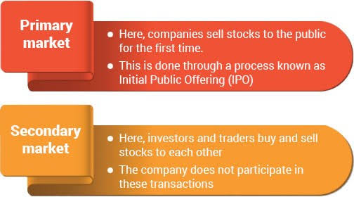

* + **Primary Market**: In the primary market, companies issue new shares to the public for the first time, usually through an **Initial Public Offering (IPO)**. The primary market allows companies to raise capital to fund operations, pay off debt, or invest in growth opportunities.
  + **Secondary Market**: After shares are issued in the primary market, they can be bought and sold by investors in the secondary market, such as the **NSE** (National Stock Exchange) or **BSE** (Bombay Stock Exchange) in India, or the **NYSE** (New York Stock Exchange) in the U.S. In the secondary market, investors trade stocks among themselves, and the price is determined by supply and demand.

**3. Key Players in the Share Market**

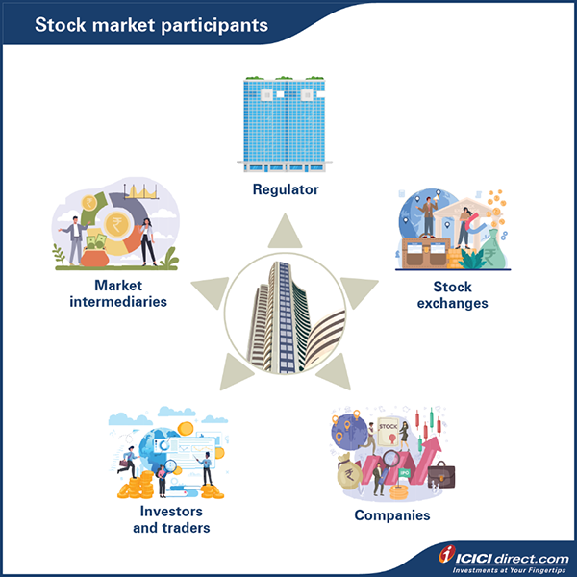

* **Investors & Traders (Retail and Institutional):**
  + **Retail Investors:** These are individual investors who buy and sell stocks for their personal investment accounts. Retail investors typically rely on brokers or online trading platforms to execute their trades.
  + **Institutional Investors:** These are large entities such as pension funds, mutual funds, hedge funds, and insurance companies that manage large pools of capital. Institutional investors often have more resources, advanced research tools, and greater influence on the market compared to retail investors.
* **Stock Exchanges (e.g., NSE, BSE, NYSE, NASDAQ):**  
  Stock exchanges are regulated markets where securities, including stocks, are listed and traded. Exchanges provide a platform for buyers and sellers to meet, ensuring transparency and fair pricing. Some of the world’s most famous exchanges include the **NYSE** and **NASDAQ** in the United States, the **London Stock Exchange** (LSE), and the **NSE** and **BSE** in India. Each exchange has its own listing requirements and operational rules.
* **Stockbrokers & Brokerage Firms**:  
  A stockbroker is a professional who facilitates the buying and selling of stocks on behalf of investors. Brokers can be full-service brokers, offering personalized investment advice and research, or discount brokers, which provide a platform for self-directed trading with minimal fees. **Brokerage firms** can be traditional (offline) or online, with many providing apps and platforms for easy access to the stock market.
* **Regulatory Bodies (e.g., SEBI, SEC)**:  
  Regulatory bodies are government or independent organizations that oversee the operations of the stock market to ensure fairness, transparency, and investor protection. For example:
  + **SEBI (Securities and Exchange Board of India)** regulates the Indian securities market, ensuring that companies and traders comply with established rules and that investors are protected from fraudulent activities.
  + **SEC (Securities and Exchange Commission)** in the U.S. monitors the stock market, enforces regulations, and ensures that the market functions smoothly, maintaining investor trust.

**4. How Does the Share Market Work?**

* **Buying and Selling of Stocks (Market Order vs. Limit Order):**
  + **Market Order**: This is an order to buy or sell a stock at the best available price in the market. A market order guarantees that the order will be executed, but the price at which the transaction occurs can fluctuate.
  + **Limit Order**: This is an order to buy or sell a stock at a specific price or better. Limit orders give you control over the price, but there's a risk that the order might not be executed if the price doesn’t reach your specified level.
* **Stock Price Determination (Supply & Demand)**:  
  Stock prices are determined by the **supply and demand** for shares. When more people want to buy a stock (high demand) than sell it (low supply), the price goes up. Conversely, when there are more sellers than buyers, the price falls. Stock prices also reflect investors' perceptions of a company's future growth, profitability, and risks.
* **Trading Sessions and Timings**:  
  Stock exchanges operate during specific trading hours, which can vary by region and exchange. For example:
  + The **NSE** and **BSE** in India are open from **9:15 AM to 3:30 PM** (Monday to Friday).
  + The **NYSE** in the U.S. is open from **9:30 AM to 4:00 PM EST**.  
    Trading can be impacted by events like earnings reports, economic announcements, and geopolitical developments.
* **Role of Stock Indices (Sensex, Nifty)**:  
  Stock indices like the **Sensex** and **Nifty** track the performance of a basket of stocks, providing an overview of the market's health. The **Sensex** tracks 30 stocks listed on the BSE, while the **Nifty** tracks 50 stocks listed on the NSE. These indices are useful for investors to gauge the overall market sentiment and economic outlook.

**5. Types of Stocks and Investments**

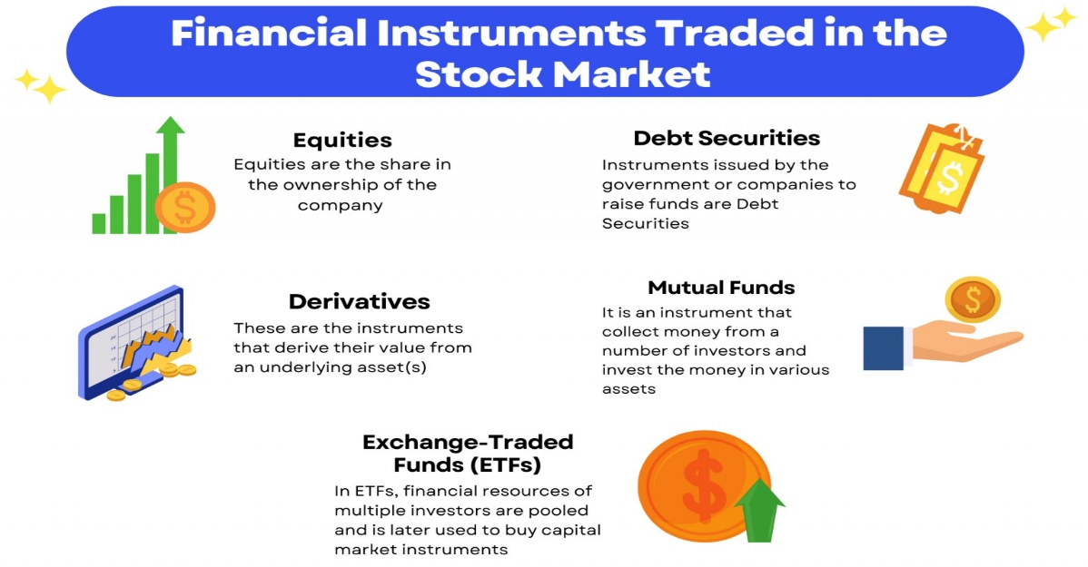

* **Equity Shares (Common vs. Preferred)**:
  + **Common Stock**: This is the most common type of stock, giving shareholders voting rights at annual meetings and a share in the company’s profits (via dividends). However, common stockholders are last in line to receive assets in case of liquidation.
  + **Preferred Stock**: Preferred stockholders have a higher claim on dividends than common stockholders and are paid before common stockholders in case of liquidation. However, they typically do not have voting rights.
* **Mutual Funds & ETFs**:
  + **Mutual Funds**: These are pools of capital from multiple investors that are managed by professional fund managers. Mutual funds invest in a diversified portfolio of stocks, bonds, or other assets, allowing smaller investors to diversify without needing to pick individual stocks.
  + **ETFs (Exchange-Traded Funds)**: ETFs are similar to mutual funds but trade on stock exchanges like individual stocks. They are often more cost-efficient and flexible than mutual funds, offering liquidity and diversification at a lower cost.
* **IPOs (Initial Public Offerings)**:  
  An **IPO** is the first time a company offers its shares to the public. Companies use IPOs to raise capital for growth, debt reduction, or other business needs. Investors who buy shares in an IPO may be able to profit if the company grows and its stock price increases after the offering.
* **Derivatives (Futures & Options)**:  
  Derivatives are financial instruments whose value is derived from the value of an underlying asset, such as a stock. Common derivatives include:
  + **Futures Contracts**: Agreements to buy or sell an asset at a predetermined price at a future date.
  + **Options Contracts**: Agreements that give investors the right, but not the obligation, to buy or sell an asset at a set price before a specified expiration date.

**6. How to Start Investing in the Share Market?**

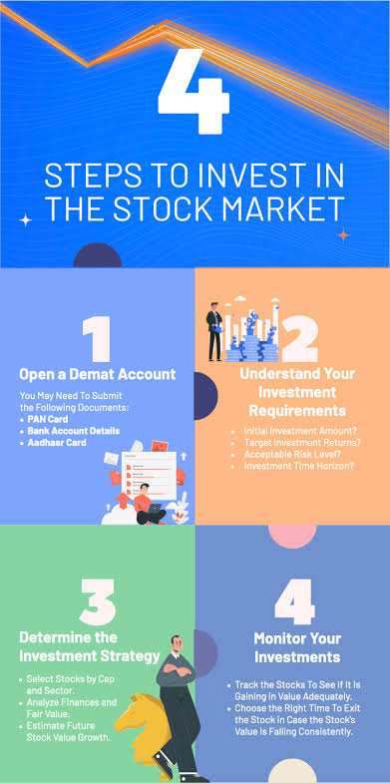

* **Open a Demat Account & Trading Account**:  
  To start investing in stocks, you need to open a **Demat account** (where your stocks are held electronically) and a **Trading account** (for executing buy and sell transactions).
* **Choose a Stockbroker**:  
  Research and select a stockbroker based on factors like fees, the platform’s ease of use, customer support, and the range of services offered. Brokers can be **full-service** or **discount** brokers, depending on your needs.
* **Learn to Analyze Stocks (Fundamental vs. Technical Analysis)**:
  + **Fundamental Analysis**: This involves analyzing a company's financial health, earnings reports, market position, and other factors to determine whether a stock is undervalued or overvalued.
  + **Technical Analysis**: This method involves studying past market data, mainly price and volume, to predict future price movements. Chart patterns and indicators are key tools in technical analysis.
* **Diversify Your Portfolio**:  
  Diversification involves spreading your investments across different types of assets or sectors to reduce risk. By owning a mix of stocks, bonds, mutual funds, and ETFs, you minimize the impact of a poor-performing investment on your overall portfolio.

**7. Risks and Challenges in Stock Market**

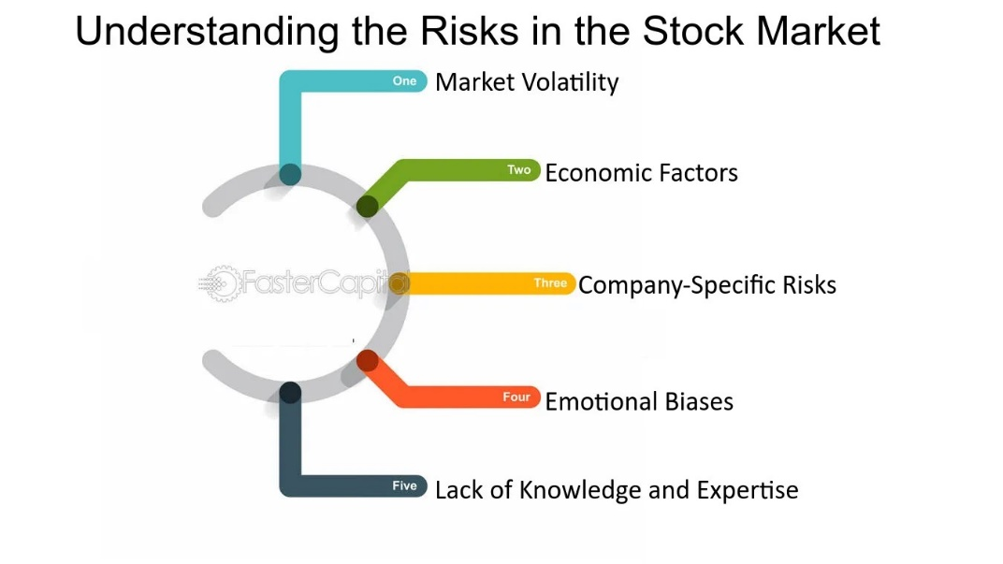

* **Market Volatility**:  
  Stock markets can experience dramatic fluctuations, especially in response to economic reports, political events, or global crises. Volatility can lead to significant short-term gains or losses.
* **Economic and Political Factors**:  
  Factors such as inflation, interest rates, government policies, trade wars, and elections can influence stock prices. For example, a change in tax laws could impact corporate profits, causing stock prices to rise or fall.
* **Emotional Investing Mistakes**:  
  Fear and greed are powerful emotions that can cloud judgment. Investors may sell during market downturns out of fear or buy based on hype without research. It's essential to stay disciplined and focused on long-term goals.

### ****8. tips of successful investing****

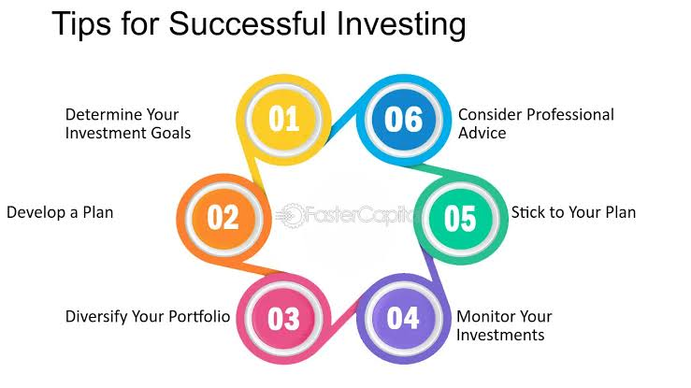

### ****1. Invest for the Long Term****

**Why It’s Important:** The stock market has historically shown growth over the long term, despite short-term volatility. When you invest for the long haul, you allow your investments to weather market fluctuations and benefit from compounding returns. Compound interest occurs when the earnings on an investment (such as dividends or interest) are reinvested to generate more earnings. Over time, this exponential growth can significantly increase the value of your portfolio.

* **Patience Pays Off**: Short-term market movements are unpredictable, but over time, markets tend to trend upwards. By staying invested, you avoid the pitfalls of trying to time the market, which can be costly and stressful.
* **Volatility is Normal**: Market downturns are inevitable, but historically, markets tend to recover. When you invest for the long term, you can hold through these periods, knowing that the market generally rises over time.
* **Tax Benefits**: In many countries, long-term capital gains (profits on assets held for over a year) are taxed at a lower rate than short-term gains. This can help you keep more of your returns.

### ****2. Keep Track of Market Trends****

**Why It’s Important:** Staying informed about financial news and economic indicators helps you make better investment decisions. By understanding macroeconomic trends (such as inflation, interest rates, and economic growth) and microeconomic conditions (like the performance of specific industries or companies), you can adapt your investment strategy accordingly.

* **Financial News**: Regularly follow reputable financial news outlets (e.g., Bloomberg, Reuters, Financial Times). They provide updates on the global economy, stock market performance, and major events that could affect investments.
* **Economic Indicators**: Key indicators like GDP growth, unemployment rates, and inflation can help you gauge the health of the economy. For instance, rising interest rates could indicate tightening monetary policy, which could lead to a slower economy and affect stock prices.
* **Sector-Specific Trends**: Be aware of trends in specific industries. For example, the tech sector may perform differently from the energy sector, depending on shifts in innovation, regulation, or market demand.
* **Timing Decisions**: While you should avoid reacting impulsively to daily market fluctuations, understanding broad trends can help you make informed decisions about buying or selling particular stocks or sectors.

### ****3. Avoid Emotional Decision-Making****

**Why It’s Important:** Emotions like fear and greed can cloud judgment and lead to impulsive decisions that harm your long-term investment strategy. It's common for investors to panic during market downturns, selling off stocks in a hurry, or to become overly confident when markets are booming, leading to overexposure in risky assets. Emotional investing can result in buying high and selling low, which is the opposite of a successful strategy.

* **Stick to Your Plan**: Developing a clear investment strategy based on your risk tolerance, time horizon, and goals is essential. Once you have a plan, stick to it rather than making decisions based on short-term market movements.
* **Market Volatility**: It’s natural for markets to fluctuate. Don't make decisions based on short-term events like market crashes or rallies. Staying calm and focused on your long-term objectives will help you avoid emotional mistakes.
* **Avoid Herd Mentality**: Just because everyone else seems to be investing in a hot stock or sector doesn’t mean it’s the right move for you. Emotional reactions to the market can lead to chasing trends and making ill-informed decisions.
* **Rebalancing, Not Reacting**: If markets dip, instead of panicking, take time to reassess your portfolio. If necessary, rebalance your investments based on your original strategy rather than reacting emotionally to short-term fluctuations.

### ****4. Continuous Learning & Research****

**Why It’s Important:** The stock market is dynamic, and financial conditions are constantly evolving. By staying curious and continuously learning, you can make better decisions and adapt to new opportunities. Additionally, understanding how the markets operate and how to evaluate stocks will help you avoid common mistakes and find potential growth opportunities.

* **Stock Market Basics**: If you're new to investing, make sure you understand the basics first—how stocks work, how bonds and other investment vehicles differ, and the fundamental principles of financial markets.
* **Investment Strategies**: Study different investment approaches, such as value investing, growth investing, and index fund investing. Understanding these strategies will allow you to develop a more nuanced investment plan tailored to your needs.
* **Company Research**: Learn how to evaluate companies before investing in their stocks. Look at financial statements, earnings reports, management, competitive positioning, and market conditions to assess the potential for growth or risk.
* **Continuous Education**: Financial markets are constantly evolving, with new tools, strategies, and investment vehicles emerging. Consider reading books, taking online courses, or following thought leaders in finance to stay on top of trends.
* **Understand Risk Management**: Learn how to manage risk within your portfolio. This might include diversifying across different sectors or using strategies like stop-loss orders to protect your investments.

### Summary of Key Concepts:

1. **Investing for the long term**: Helps you take advantage of the stock market's historical growth, reduce risk, and capitalize on compounding returns.
2. **Tracking market trends**: Staying informed allows you to make more timely and informed decisions based on economic and industry shifts.
3. **Avoiding emotional decision-making**: Sticking to your strategy and not reacting to short-term market movements prevents impulsive and often costly decisions.
4. **Continuous learning & research**: The more you learn about markets, companies, and investment strategies, the better equipped you will be to make sound, informed decisions over time.

By incorporating these strategies into your investment approach, you improve your chances of achieving long-term financial success while managing risk and avoiding common pitfalls.

**9. Conclusion**

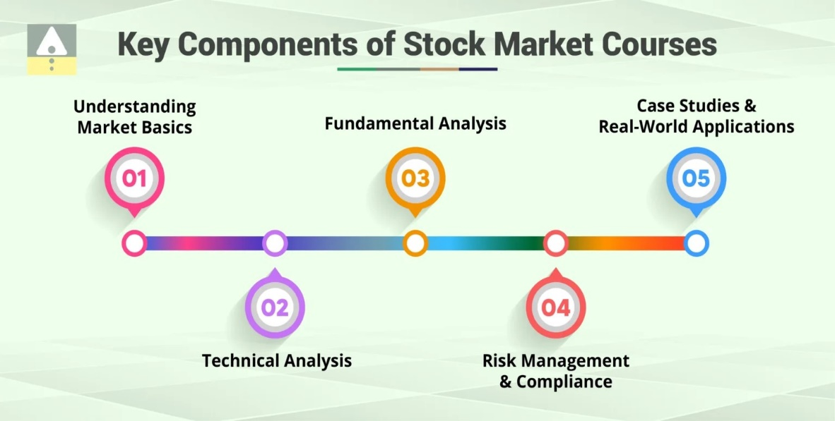

* **Recap of Key Points**:  
  Understanding how the stock market works, the types of investments available, and the factors that influence stock prices will help you navigate the stock market successfully. It's crucial to have a solid strategy and manage risks effectively.
* **Encouragement to Invest Wisely**:  
  While the stock market offers opportunities for significant returns, it is essential to be cautious, make informed decisions, and think long-term. By doing your research and staying disciplined, you can make the stock market work for you.

### ****Frequently Asked Questions (FAQ)****

**1. What is the share market?**

The share market, also known as the stock market, is a marketplace where stocks (or shares) of publicly listed companies are bought and sold. It provides a platform for companies to raise capital by issuing shares, and for investors to buy or sell these shares.

**2. How do I start investing in the share market?**

To start investing, you need a trading account and a Demat account, which you can open with a registered broker or financial institution. After opening the accounts, you can start buying shares through the broker's platform.

**3. What are stocks or shares?**

Stocks (or shares) represent ownership in a company. When you buy shares, you are purchasing a small ownership stake in that company, and your wealth can increase or decrease based on the company's performance and market conditions.

**4. What is an IPO (Initial Public Offering)?**

An IPO is when a private company offers its shares to the public for the first time. This allows the company to raise capital by selling ownership stakes to investors.

5.**What is market capitalization?**

Market capitalization (market cap) refers to the total market value of a company’s outstanding shares, calculated by multiplying the share price by the total number of shares. It is often used to classify companies into small-cap, mid-cap, and large-cap categories.

**6.What is a stock exchange ?**

A stock exchange is a regulated marketplace where securities (stocks, bonds, etc.) are bought and sold. Some well-known stock exchanges include the New York Stock Exchange (NYSE), Nasdaq, and the Bombay Stock Exchange (BSE).

**7. What is the role of the SEBI?**

The Securities and Exchange Board of India (SEBI) is the regulatory body that oversees the securities markets in India. SEBI's role includes ensuring fair practices, protecting investor interests, and promoting transparency in the market.

**8. What is technical analysis?**

Technical analysis involves evaluating and predicting stock price movements based on historical data, charts, and various indicators. It is used to identify trends and make decisions about buying or selling stocks.

**9. What is fundamental analysis?**

Fundamental analysis involves evaluating a company’s financial health, performance, industry position, and other fundamental factors to determine the stock’s intrinsic value. It includes studying financial statements, earnings reports, and economic conditions.

**10. Can I lose all my money in the stock market?**

Yes, it is possible to lose money in the stock market, especially if you invest in high-risk stocks or do not manage your investments wisely. However, with a well-thought-out investment strategy, diversification, and long-term approach, you can mitigate risks and increase the chances of making profits.

This FAQ section provides a comprehensive overview of the share market, covering essential concepts, terms, and practices that anyone entering the market should know.